|  |
| --- |
| Creating Web Application |
| COS10011  Semester 1, 2021 |
|  |
|  |
|  |

|  |  |
| --- | --- |
| Member Name | Member ID |
| Jamie Jasmine Koh | 101233988 |

|  |
| --- |
|  |

**Table of Contents**

**Assignment 1 Tome Times** 1

**1. Introduction** 1

**1.1 Scope** 1

**1.2 Target Audience** 1

**2. Webpage Design and Structure** 2

**2.1 Website Layouts** 2

**2.2 Website Structure** 6

**3 End Product** 7

**3.1 Actual User Interface** 7

**3.2 Enhancements** 11

**Assignment 2** 12

**1 Description** 12

**2 End Product** 12

**2.1 Enhancements (if any)** 12

**Assignment 3** 13

**1 Description** 13

**2 MySQL database structure/schema** 13

**3 End Product** 13

**3.1Enhancements (if any)** 13

**References** 13

# 

# **Assignment 1 Tome Times**

## **1. Introduction**

The production of books is important. According to The Scientific World, reading has numerous benefits: reducing stress and increasing problem-solving capabilities in an individual (2021). Tome Times is a website that provides services to authors. The process of writing and publishing books is made easier in the hope that it can encourage more people to produce more written works. To provide further encouragement, the website caters to many book genres such as fiction, education, non-fiction, and literature.

### **1.1 Scope**

Tome Times covers a broad scope in the book industry. The services offered by Tome Times can be divided into four main categories which are:

#### **Producing services**

* Editing services which help authors avoid tedious work such as combing through hundreds of pages, looking for spelling mistakes.
* Beta readers who may review and offer constructive advice to authors.
* Cover artists who can be commissioned to design a suitable cover for the books of authors.
* Narrating services for authors who are interested in producing an audiobook.

#### **Publishing services**

* Hardback versions
* Paperback versions
* Electronic/e-book versions
* Audiobook versions

#### **Marketing services**

* Distribution to Tome Times stores
* Distribution to Amazon
* Distribution to Barnes and Noble stores
* Distribution to Shopee

#### **Promoting services**

* Opportunity to place an advertisement in newspapers.
* Opportunity to place an advertisement in a themed magazine related to the type of book.
* Books or advertisements of books can be promoted at a Tome Times book fair.
* Opportunity for a shoutout on the official Tome Times Instagram page

### **1.2 Target Audience**

Tome Times’ target audience is authors looking to produce, publish, promote, or market their books.

## **2. Webpage Design and Structure**

### **2.1 Website Layouts**

#### **Index (Home page) Wireframe**

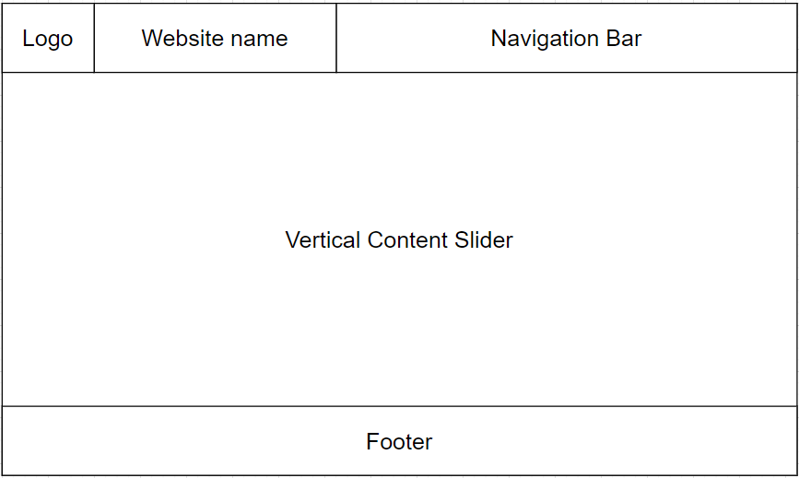

#### **Service Pages Wireframe**

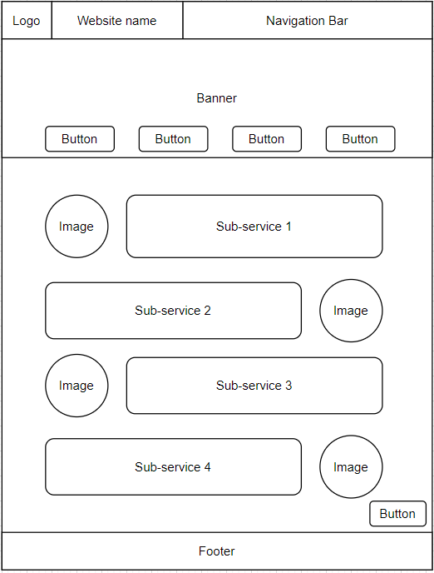

#### **Enquiry Page Wireframe**

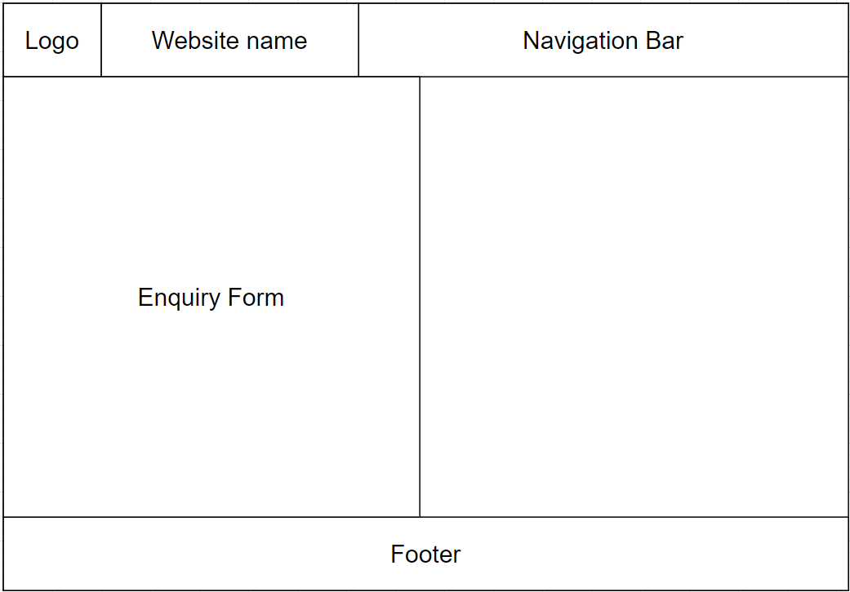

#### **Disclaimer Page Wireframe**

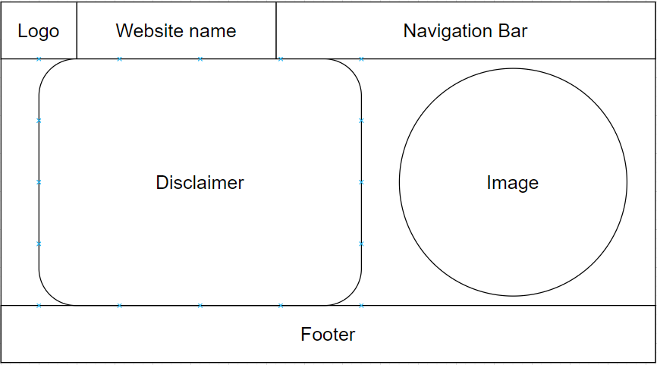

#### **Profile Page Wireframe**

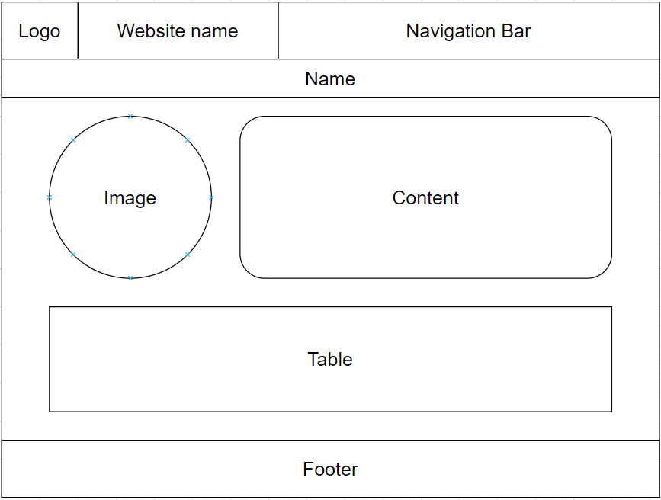

#### **Enhancements Page Wireframe**

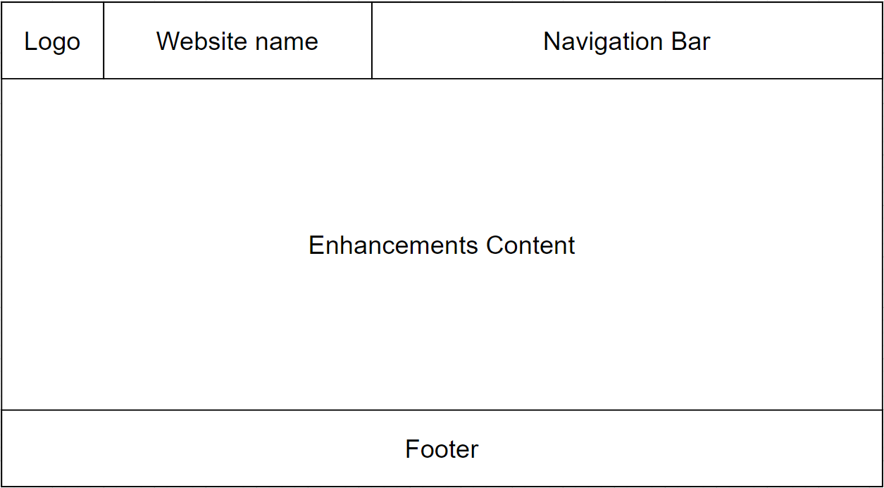

### **2.2 Website Structure**

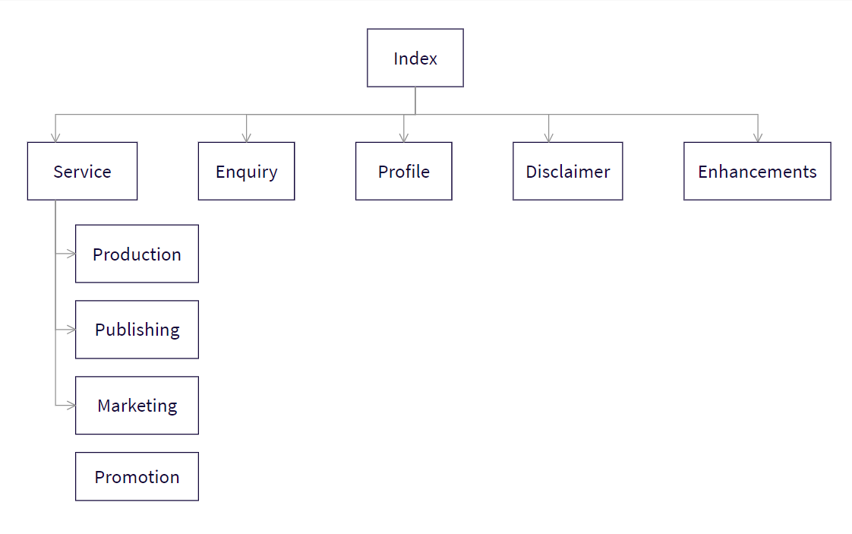

## **3 End Product**

### **3.1 Actual User Interface**

The interface of the web pages features abstract illustrations and a consistent colour scheme. The website also uses the same font (sans serif) and font colour (white) to give the website a clean and consistent look. In some areas, the text even has a slight grey text-shadow so that they are more distinguishable from the lighter backgrounds. Visually, the web pages have colours that are soothing to the eyes so that the visitors are not uncomfortable after looking at the web pages for a long time. Therefore, the web pages’ primary colours are dark blue, green and beige with some accent colours like red, orange and yellow to add pops of colour. The logo on the top left corner of each web page is simple and leads to the home page when clicked. It also rotates 360 degrees clockwise when the mouse is hovered over it to make the web pages more attractive. For the same reason, the social media icons in the footer rotate 360 degrees on hover as well.

#### **Index Page Design**

The home page consists of a vertical content slider with a fixed navigation bar and footer. The content on this page serves to captivate the interest of visitors and provide a general introduction to the rest of the website.

To help captivate the visitor’s attention, the home page is designed with several responsive and moving features. For example, the text on the very first slide fluidly slides into view. The message itself is a simple welcome to the website, so the sliding animation helps make the page more interesting.

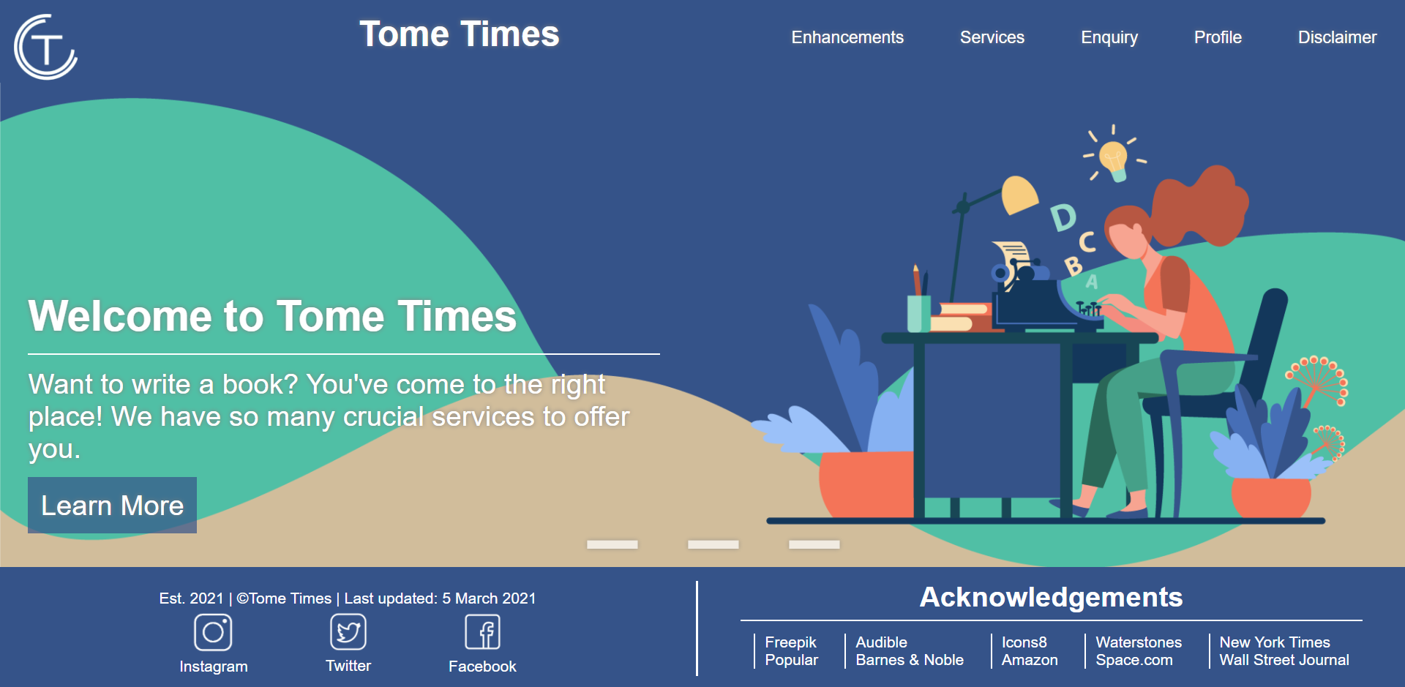

The second slide gives the visitors a general idea of the website’s function. To avoid having too many words on the slide, the four primary services are displayed in an automatic moving text slider that shows one word at a time. This text slider also helps captivate the visitor’s attention.

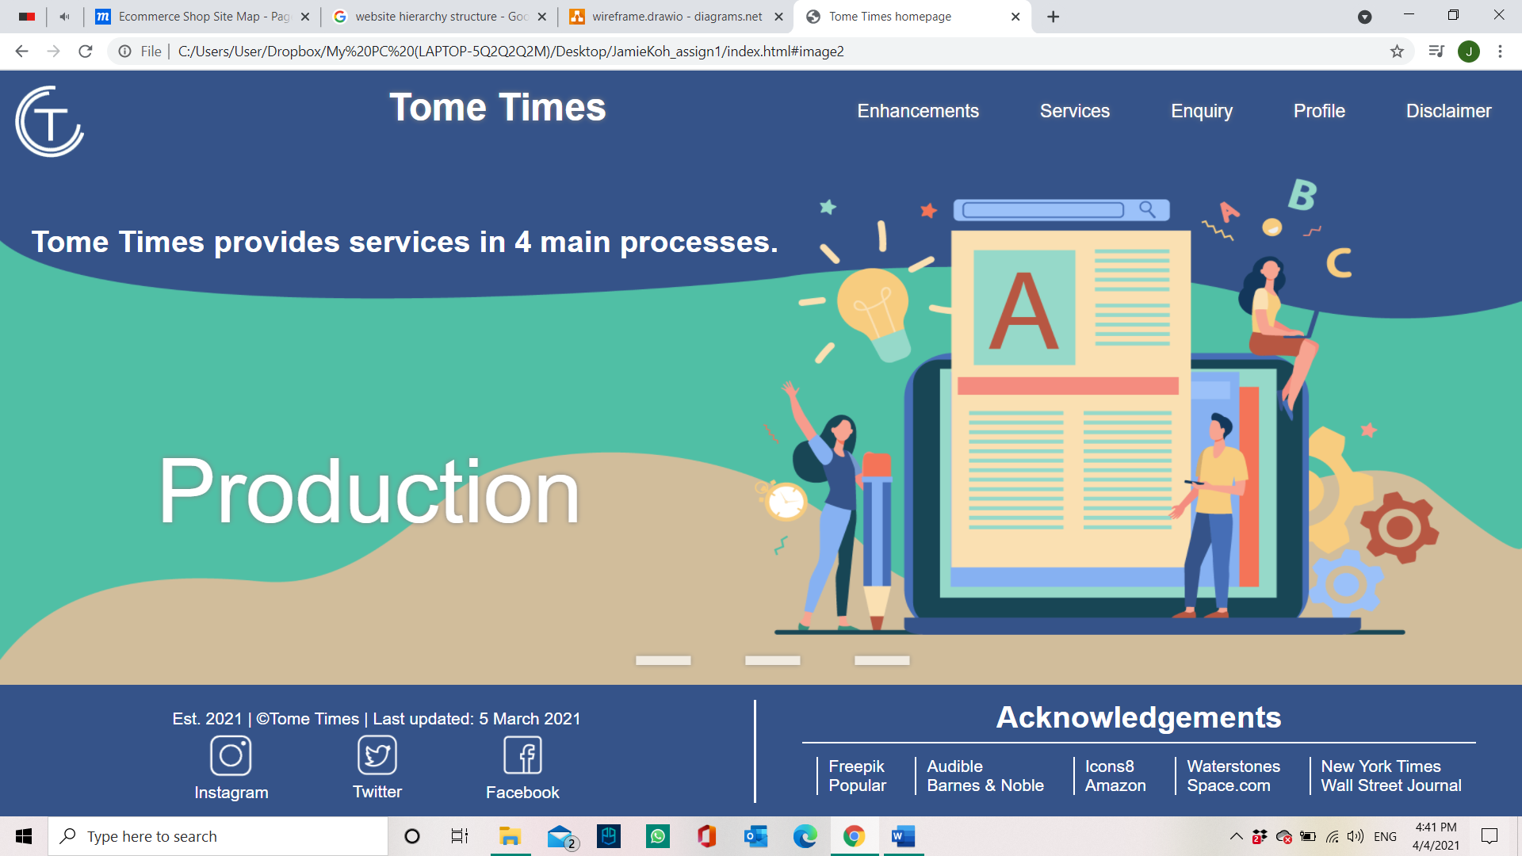

#### **Design For Service Pages**

All four service pages adhere to the same wireframe since each page elaborates on four sub-services. The top of each web page has a banner illustration and title of the service.



Just below the banner, four buttons act as shortcuts to each sub-service to increase the accessibility of the web pages. They even change colours when the mouse hovers over them. Short paragraphs which elaborate on each sub-service are placed one above the other in coloured boxes. Circular images that illustrate each sub-serviced are placed on varying sides of the text to help the reader better understand each explanation. Within each sub-service box, there is also an enquire button that is a shortcut to lead the users to the enquiry form. All the service pages also have a “Back to top” button fixed permanently somewhere on the screen's bottom right. This way, it will be more convenient for the visitors to go back to the top of the service pages since they will not have to scroll through all the content.

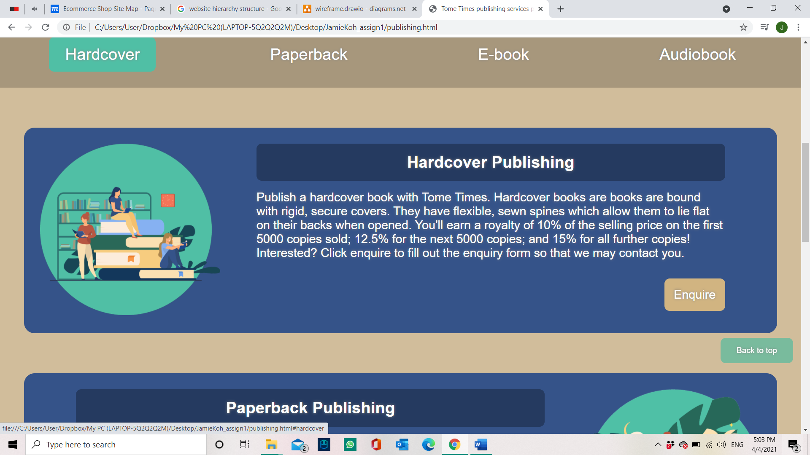

#### **Disclaimer Page Design**

The disclaimer page features a straightforward design with a card with the disclaimer text and a fun background image to fill up the empty space on the screen.

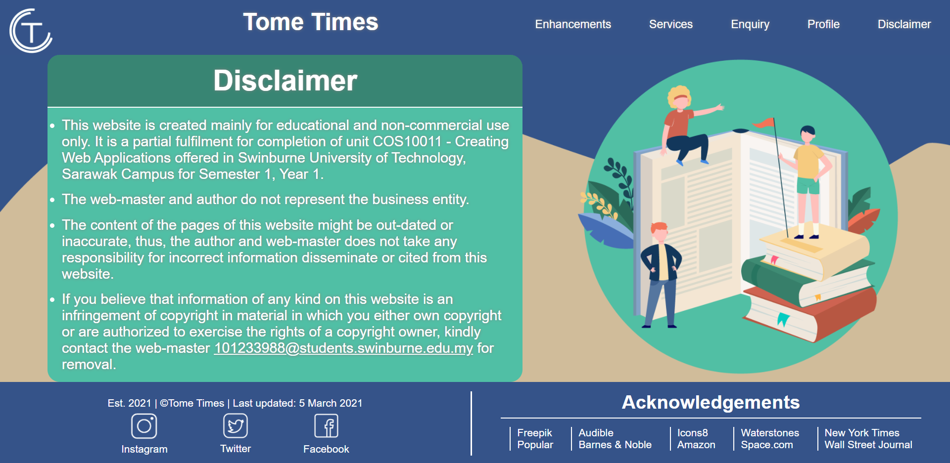

#### **Profile Page Design**

The assignment requirements largely influenced the design of the profile page since some elements were to be specifically positioned. Thus, the footer of this page has extra information compared to the other pages



#### **Enquiry Page Design**

Since this page included a form that visitors are supposed to fill instead of just content to read, the enquiry page uses more of the darker colours present throughout the website. The colours are unique but are not too far different from the colours of the other web pages.

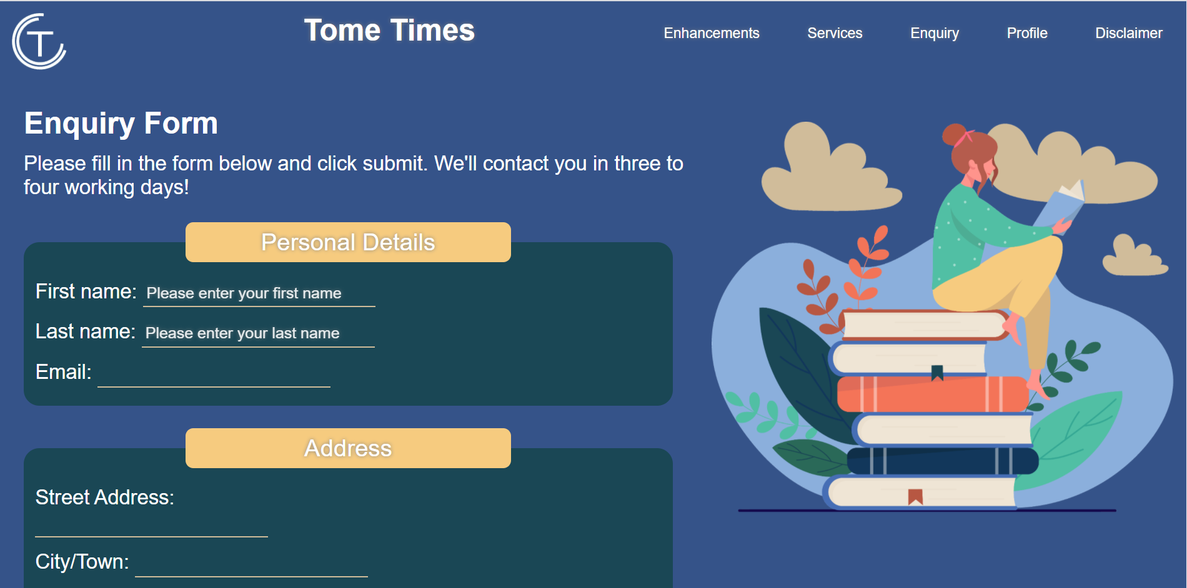

#### **Enhancements Page Design**

The enhancements page, like the disclaimer page, is straightforward. There is no illustration or cute abstract art since this page is mainly for linking to the enhancements and does not serve the hypothetical company visitor any purpose.

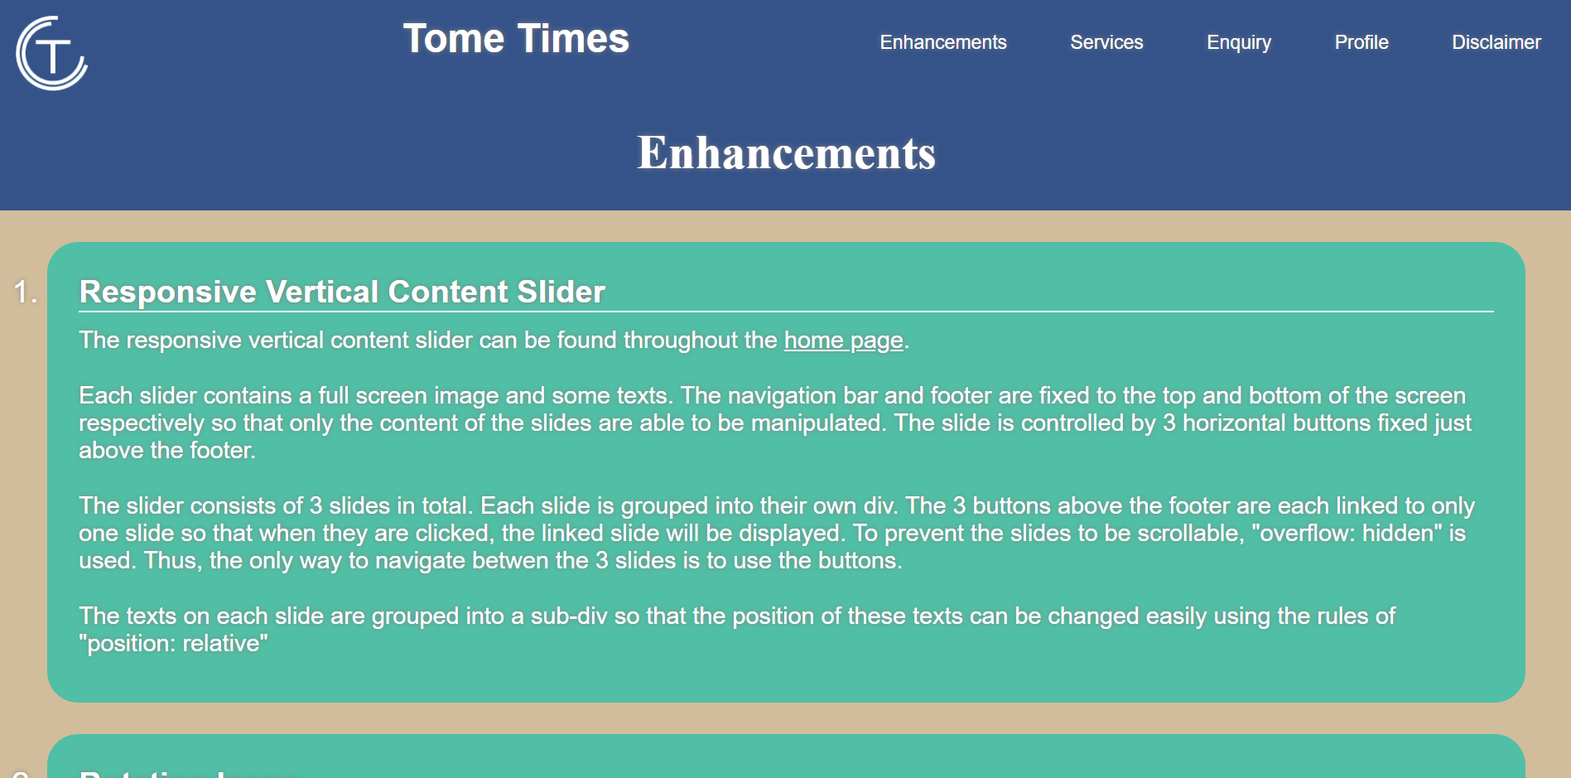

### **3.2 Enhancements**

#### **Responsive Vertical Content Slider**

The responsive vertical content slider can be found throughout the home page. Each slider contains a full screen image and some texts. The navigation bar and footer are fixed to the top and bottom of the screen respectively so that only the content of the slides are able to be manipulated. The slide is controlled by three horizontal buttons fixed just above the footer.

The slider consists of three slides in total. Each slide is grouped into their own div. The 3 buttons above the footer are each linked to only one slide so that when they are clicked, the linked slide will be displayed. To prevent the slides to be scrollable, "overflow: hidden" is used. Thus, the only way to navigate between the three slides is to use the buttons.

The texts on each slide are grouped into a sub-div so that the position of these texts can be changed easily using the rules of "position: relative"

#### **Rotating Icons**

The rotating icons are used in the navigation bars and footers of every webpage of the website. The icons referred to are the social media icons in the footers and the website logo on the top left corner of the navigation bars. The icons were downloaded from Icons8 and only the Instagram icon went through editing in Adobe Illustrator to make the white outline as thick as the other icons. The website logo was created from scratch in Adobe Illustrator.

Hovering over the social media icons will cause the icons to rotate 360 degrees clockwise in 1 second while hovering over the website logo will cause the logo to rotate 260 degrees clockwise in 0.6 seconds.

This was done by using the "transform: rotate" property, setting the rotation to 360 degrees on hover combined with setting the transition time of the elements to determine how long it takes for the rotation to complete.

#### **Automatic Text Slider**

The automatic text slider can be found on the second slide in the home page. The sliding text is actually a string of four words arranged vertically one after the other. A small window large enough for only one word is set and the other three words that don't fit into the window are hidden.

Then, an animation cycle is created using keyframes to increase and decrease the margin of the string of words at specific intervals. This way, when the margin increases or decreases, the whole string of words moves up or down the web page. So, the previously hidden word is pushed to the small window and is visible. When the margin is increased or decreased again, the next word will be pushed to take over the previous word at the window. This cycle is automatic and does not stop.

#### **Sliding Text**

The sliding texts appear in the first slide of the home page. Since the first slide is the first content a visitor would see in the home page, I used sliding text as an attention grabber.

The sliding texts work similarly to the automatic text slider in the second slide. The difference is that the animation only takes place once before it stops instead of repeating itself in a never-ending loop.

It works by setting the initial right margin of the text to a value that would push the text out of view to the left. Then the right margin slowly decreases, making room for the text to slide into view until the entirety of the message is settled nicely in the view screen where it is supposed to be.

# **Assignment 2**

## **1 Description**

JavaScript was applied to this assignment to improve functionality in three aspects: form validation, data transfer between pages, and to enhance the responsive content slider with previous and next buttons.

### **Form Validation**

Using JavaScript codes, the website now has the added function of producing a pop-up message to alert the user that certain parts of their entries in the enquiry form have not satisfied a predetermined condition.

The codes were written in a way where each answer that is inputted by the user goes through a JavaScript function which checks to make sure that the input is valid. For example, upon clicking the enquire button, the name that the user has keyed in will go through the JavaScript checking process to make sure it is not empty and consists only of alpha characters.

### **Data Transfer**

#### **Data Transfer Within A Web Page**

In the html code, the checkbox input fields that were used to indicate the subject on which the user would like to enquire was modified to be handled by a single text field and a dropdown list.

Data transfer within the enquiry form page allowed the users to select an option from the dropdown list and automatically display the chosen option in the subject text field.

This was done by first using JavaScript to create an array of options under the dropdown list to be chosen from. Then, the option that the user chooses is stored to the session storage of the device. Finally, whatever has been stored to the session storage will be displayed on the text field.

For example, if the user chooses “editors” from the dropdown list, then the word “editors” will be stored to the session storage and will be displayed on the text field.

#### **Data Transfer Between Web Pages**

Data transfer between web pages allows the subject field to be automatically filled if the user selects the enquire button from one of the service pages. For example, should the user be browsing through the production services page of the website and clicks the enquire button under the “editors” information, they will be taken to the enquiry form page in which the subject of enquiry text field will already display the word “editors”.

This is made possible by using a JavaScript function that stores the word “editors” into the session storage when the enquiry button under the “editors” information is clicked. When the enquiry form is loaded, the subject text field will display whatever is in the session storage, which, in this case, is the word “editors”.

## **2 End Product**

### **2.1 Enhancements (if any)**

#### **Enhanced Responsive Content Slider**

In assignment 1, a responsive content slider was featured in the home page of the website. The slider was coded with basic html and css and could only be controlled using three buttons positioned near the bottom of the screen. To enhance the slider, all control of the slides were modified so that they would fall to the hands of JavaScript codes.

It is enhanced from the previous slider by using JavaScript to add next and previous arrows while also changing the button navigation to be controlled by JavaScript codes instead of html codes. Since there are only three slides, each slide is assigned a number from one to 3. These numbers are manipulated using a counter in functions in JavaScript that are called when a navigation button is clicked.

The counter automatically starts off at 1 since the first slide will be presented when the page is first loaded. Upon clicking the next button, the counter increases to 2 and the slide changes. If the user presses the next button after the counter has reached a value of 3, the counter is reset to a value of 1.

Similarly, if the user clicks on the previous button, the value of the counter will be decremented by 1 unless the value is 1. In which case, the counter will be set to 3 so that when the user clicks on the previous button while on the first slide, the result is the 3rd slide will appear.

As for the 3 buttons on the bottom of the slides, there is no incrementing or decrementing the value of the counter. Upon clicking a specific button, the counter is manually set to the number of the appropriate slide. This way, the codes are easy to read and simple to write since the number of slides being manipulated is small.

# **Assignment 3**

## **1 Description**

### **Separate header and footer**

The header and footer of every web page was the same, therefore using php, the header codes were written once in a “navbar.php” file and the footer codes were written once in a “footer.php” file.

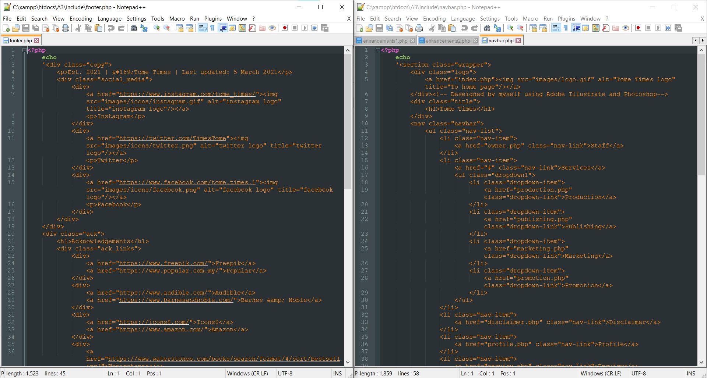

These files were then placed in a folder named “include” so that the files were organized. In place of the navigation bar and the footer codes that used to be on each web page, the php function “include()” was utilized in every web page as a replacement.

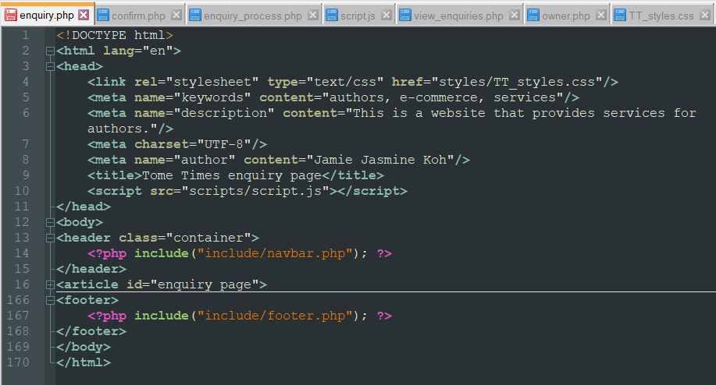

### **Creation of Database and Table**

Inside the “enquiry.php” page, several lines of php codes would create a database named “Enquiry” if one does not exist and a table called “EnquiryDetails” if such a table does not already exist inside the Enquiry database. There is also a checking process every step of the way to ensure that the connection to the database is stable.

### **Submission of enquiry form**

The form submission goes through 3 web pages or 3 steps. It starts out at the “enquiry.php” page which is where the database and table are created and the user fills in the enquiry form. Upon submission, the enquiry form will post the values collected to “confirm.php”. Further explanation of the confirm page is discussed in the enhancements section of assignment 3 because it was not specified as a basic requirement in the assignment brief. Clicking the submit button on the “confirm.php” page will send those same values to the “enquiry_process.php” page. In this page, the values will be stored into the appropriate fields of the table created in the “enquiry.php”. If this action is successful, the user will be notified with a message that their submission was recorded and if not, an error message will be displayed instead/

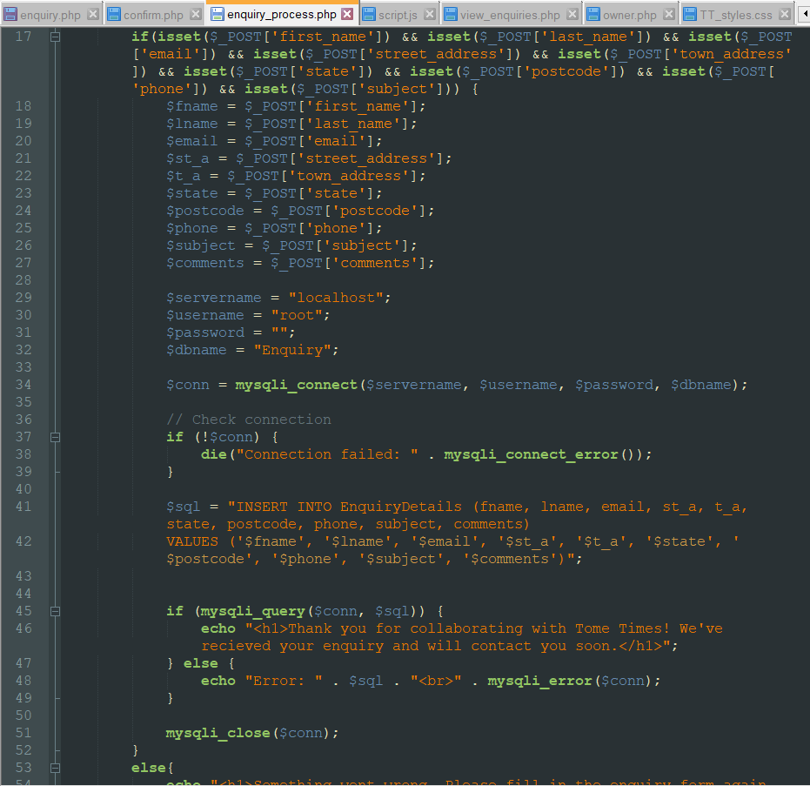

### **Viewing of recorded enquiry details**

In the “view_enquiries.php” page, the user will be able to view a table with all the recorded values of the enquiry form submissions if they are authorized. Authorization will be discussed in the enhancement section later. Once the user is verified, the php checks if the record of enquiry details contains anything by setting an if loop with a condition of the number of rows in the table is more than 0. If it is determined that the table is empty, the user will be notified through a message informing them that 0 results were found. If not, a table of enquiries will be formed and the first row will be statically written in to display the main headings of the columns. Then a while loop is created to loop through all the rows in the “EnquiryDetails” table. Each field from each row is displayed into a row with each index occupying 1 table cell. This is done by putting the <tr> tag at the start and its closing at the end, and enclosing each index item in a <td> tag.

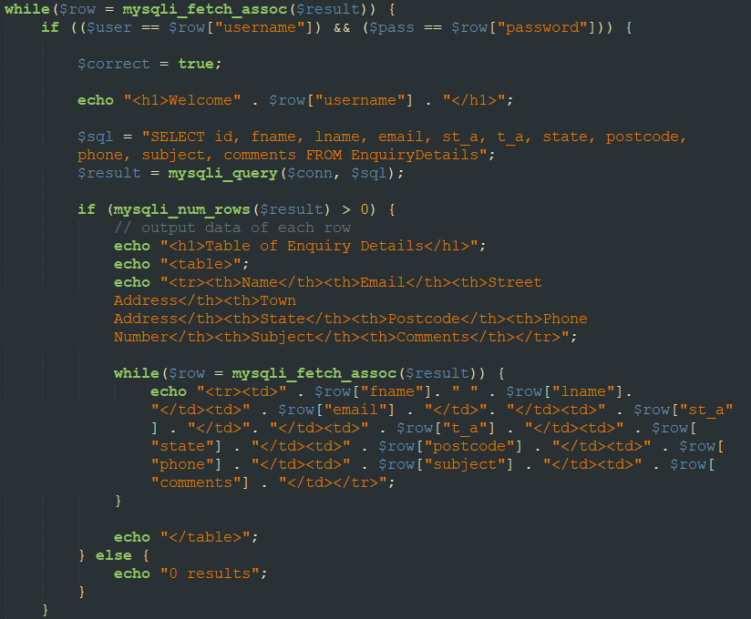

## **MySQL database structure/schema**

Two tables were included in the “Enquiry” Database. EnquiryDetails table to store the inputted values from the enquiry form and the UserDetails table to store the username and password of the owner.

|  |  |
| --- | --- |
| fname | VARCHAR(50) NOT NULL |
| lname | VARCHAR(50) NOT NULL |
| email | VARCHAR(50) NOT NULL |
| st_a | VARCHAR(100) NOT NULL |
| t_a | VARCHAR(100) NOT NULL |
| state | VARCHAR(30) NOT NULL |
| postcode | VARCHAR(30) NOT NULL |
| phone | VARCHAR(30) NOT NULL |
| subject | VARCHAR(100) NOT NULL |
| comments | VARCHAR(300) |

Table : EnquiryDetails table

|  |  |
| --- | --- |
| username | VARCHAR(50) NOT NULL |
| password | VARCHAR(50) NOT NULL |

Table : UserDetails table

## **3 End Product**

### **3.1Enhancements (if any)**

### **Confirm.php**

This page will use php to assign each input that was posted from the “enquiry.php” to a variable, then set each variable to an invisible input and display those variables in a form for the user to read through and confirm. This form uses the post method as well and upon submission, will post the hidden inputted values to the “enquiry_process.php” page.

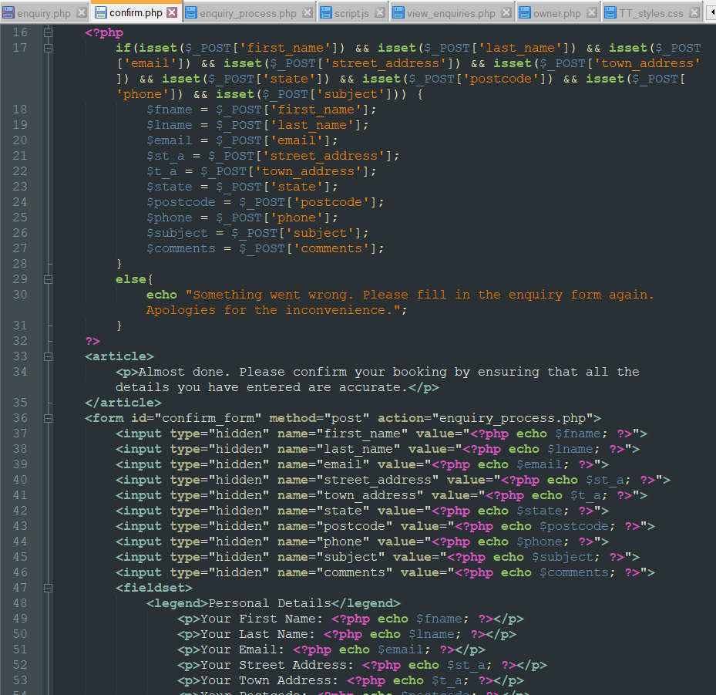

### **User Authorization**

The user authorization involves 2 web pages. “owner.php” and “view_entries.php”. The “owner.php” page works similar to the enquiry form page wherein it creates a "User Details" table containing a username and a password if such a table does not already exist. On screen, the user is required to enter their username and password. Upon submission, the user will be redirected to a view enquiries”page. This page will perform a checking process by comparing the inputted username and password to the username and password in the "User Details" table. Only if both entries match, shall the "view enquiry" page display the table of enquiry details recorded upon confirmation of the enquiry form.

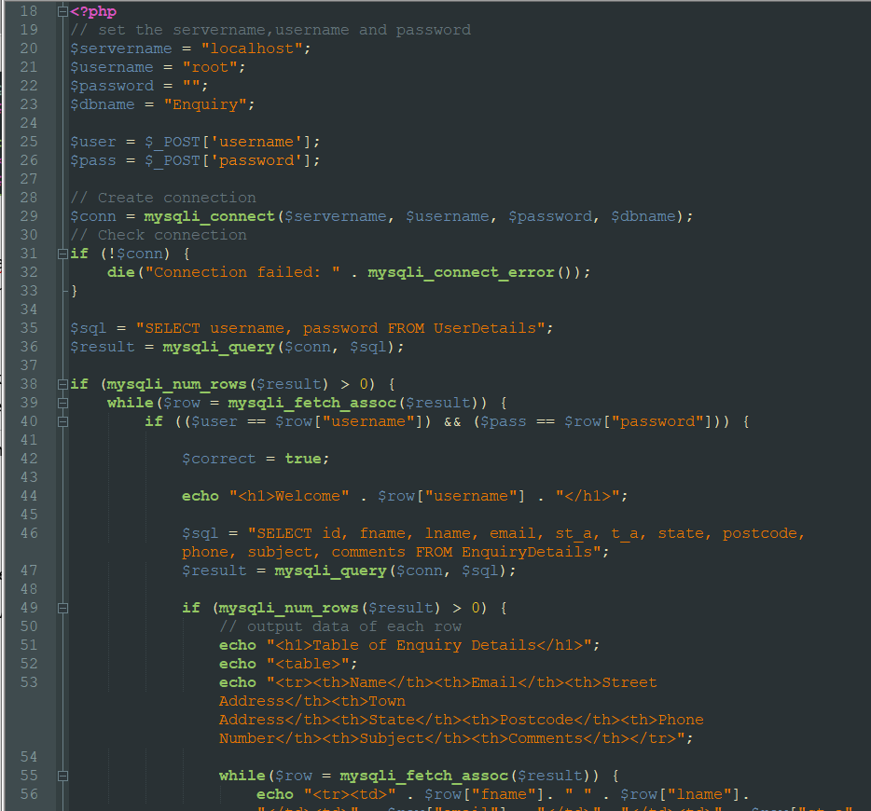

**References**

The Scientific World 2021, *Why Should You Read Every Day: Scientific Benefits of Reading Books*, The Scientific World, viewed 2 March 2021, <https://www.scientificworldinfo.com/2021/03/why-you-should-read-every-day.html>.